EXPERIMENT- 18
Perform Edge Detection using Sobel Matrix along Y-axis
Aim
To write a Python code to detect vertical edges in an image using the Sobel Y operator in OpenCV.
Input Image

Code
import cv2
import numpy as np
from google.colab.patches import cv2_imshow
from google.colab import files
uploaded=files.upload()
image_path=list(uploaded.keys())[0]
image=cv2.imread(image_path,cv2.IMREAD_GRAYSCALE)
if image is None:
print("Error: Image not found")
else:
sobel_y=cv2.Sobel(image,cv2.CV_64F,0,1,ksize=3)
sobel_y=np.uint8(np.absolute(sobel_y))
print("Original Image")
cv2_imshow(image)
print("Sobel Y Image")
cv2_imshow(sobel_y)
Output Image
Sobel Y Edge Image
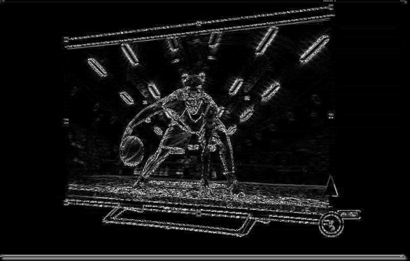
Result
Thus, vertical edges were successfully detected using the Sobel Y operator in OpenCV.

